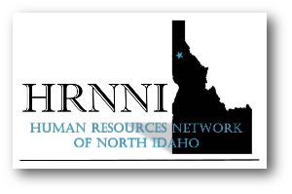 About Us…
The Human Resource Network of North Idaho is an informal networking group of human
resource and management professional who meet on a regular basis to discuss employment
issues, laws, and legislation. We also have fun and provide an opportunity to network with
people who may provide resources regarding employment, personal and organizational development.
We do not sell our mailing lists nor do we encourage our members to use the membership
list for solicitation purposes.

Meeting location: CDA Inn (Best Western) on the 3rd Wednesday of the month.
11:15 check-in, 11:30 lunch and networking 12-1 Speaker.
Our format is a no-host luncheon and non-refundable for non-cancellation at least 72 hours prior.
Members – Please bring cash, credit card or check for $17 payable to HRNNI for lunch buffet,
or $5 for “beverage only”. Non-Members may attend for $25 for lunch buffet,
or $15 for beverage only option.

Our website www.hrnni.org or email us at hrnniofidaho@gmail.com

MEMBERSHIP APPLICATION FORM – HRNNI

Full Name: | Click or tap here to enter text.
Email: | Click or tap here to enter text.
Phone Number: | Click or tap here to enter text.
Your Company Name | Click or tap here to enter text.
How did you hear about HRNNI? | Click or tap here to enter text.
What is your main reason(s) for joining HRNNI? | Click or tap here to enter text.
Short Bio (3-4 sentence):Click or tap here to enter text.

Annual Dues (January – December) $40 per person,
Send your check (only) to:
HRNNI – 212 W. Ironwood Drive, Ste D, PMB 238, Coeur d’Alene, ID 83814
”Like” us on Facebook!

